SQL PROJECT

Name of the Project:

XYZ Paints Inc. Marketing Campaign Analysis

Done By : TANMAY SAHA

DESCRIPTION

XYZ Paints Inc. is a paint company which was recently launched in 2019. Since then, they have established their name in top tier 1 and 2 cities (slowly expanding to tier 3 cities as well).

They have orders coming from household, industrial and government sectors. In recent years, they are seeing quite a steady growth and would like to continue that in future.

They have hired you as a Data Scientist in their data consulting team which offers services across various departments such as sales, marketing, logistics, etc.

OBJECTIVE

They have given you a sample of data from their databases. You have to work on some of the pain points of the marketing team like consumer growth, lead conversions, etc. as well as help them work on new set of campaigns or doing market basket analysis.

Dataset Description

Name of the tables:

* **Customer :** This table stores information about customers, including their customer ID (primary key), name, gender, city ID (foreign key referencing the City table), pincode, birthdate, income bracket, email address, and phone number.
* **Item :** This table stores information about items, including their item ID (primary key), item name, item category, price, and quantity.
* **CustomerTransactionData :** This table stores information about customer transactions, shown here include transaction ID (primary key), customer ID (foreign key referencing the Customer table), and campaign ID (foreign key referencing the Campaign table).
* **CouponMapping :** This table stores information about coupon mappings, but it likely has more columns than those shown in the ERD. The ones shown here include coupon ID (primary key), item ID (foreign key referencing the Item table), and minimum purchase required for the coupon.
* **CityData :** This table stores information about cities, including their city ID (primary key), city name, state, and city tier.
* **Campaign :**This table stores information about campaigns, including their campaign ID (primary key), campaign type, start date, and end date.

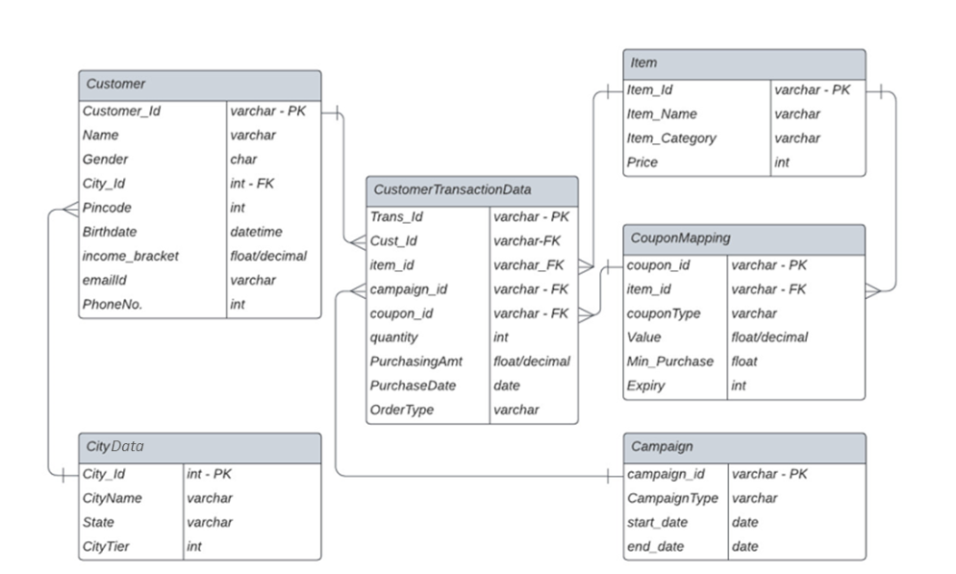Table Schema: